**Chapter 8 - Plant Physiology**

**All Lectures Uploaded on YouTube:**

[**https://tinyurl.com/fkm9-biology**](https://tinyurl.com/fkm9-biology)



**Plant physiology** is a branch of *botany* focusing on how plants grow, absorb nutrients, exchange gases, adapt to environmental changes, and reproduce.

**8.1. Nutrition in Plants:** 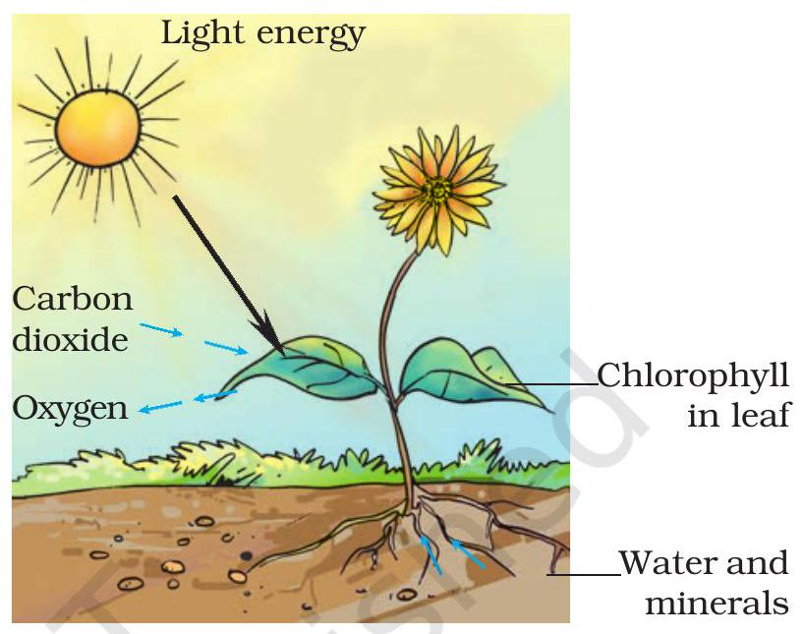

* A nutrient is any substance or element which is important for growth and metabolism
* Nutrients can be organic (carbon-based) or inorganic in nature
* Plant nutrients are inorganic
* Plants are **autotrophs,** obtaining nutrients like water, CO₂, and minerals from the environment to make organic compounds.

**8.1.1. Types Of Plant Nutrients:**

* Sixteen elements are essential for plant growth.
* **Macronutrients** (needed in large quantities, >0.05% dry weight):
* Carbon, hydrogen, oxygen, nitrogen, phosphorus, potassium, sulfur, calcium, and magnesium.
* **Micronutrients** (needed in trace amounts, <0.05% dry weight):
* Iron, boron, manganese, copper, molybdenum, chlorine, zinc.

**Importance of Nitrogen in Protein Synthesis:**

* Nitrogen is a macronutrient absorbed through plant roots in inorganic forms like *nitrates* (**NO₃⁻**).
* Major nitrogen source: Decomposition of dead organic matter in the soil.
* Nitrogenous compounds are used to make nucleotides, amino acids and chlorophyll
* In nitrogen-deficient soils, fertilizers can be used to supply nitrogen.
* Nitrogen deficiency effects:
* a. Growth retardation and,
* b. Chlorosis (yellowing of leaves) due to reduced chlorophyll formation.

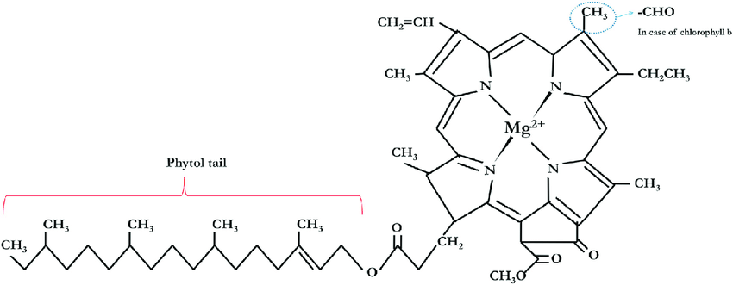

**Importance of Magnesium in Chlorophyll Formation:**

* Magnesium is a macronutrient absorbed as **Mg²⁺** ions.
* Main source: Decomposed plant debris.
* In magnesium-deficient soils, fertilisers like Magnesium sulfate (MgSO₄) or dolomitic limestone are added.
* Essential for chlorophyll production
* Magnesium deficiency effects: Chlorosis (yellowing of leaves)

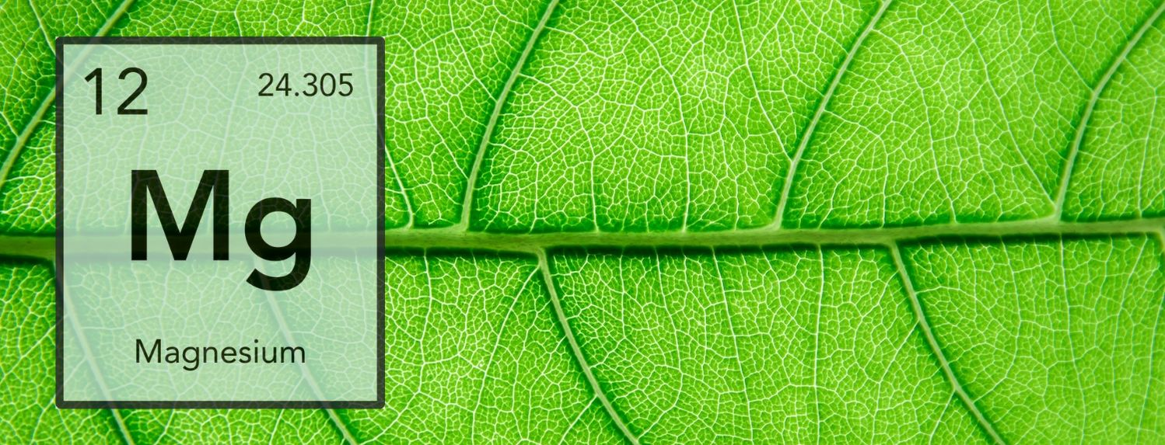

**8.2. Transport in Plants**

**8.2.1. Need For Transport:**

Transport in plants occurs at three levels:

1. **First Level** (Absorption from Environment)

* Nutrients and water are absorbed from the soil by roots.
* Gases like CO₂ and O₂ are obtained from the air.

2. **Second Level** (Internal Movement)

* Inorganic nutrients are transported to leaves for photosynthesis.
* Organic solutes are transported to different parts of the plant.

3. **Third Level** (Removal of Waste)

* Waste compounds are excreted from the plant's body.

**8.2.2. Structure Of Root And Root Hairs:**

* **Root**: Underground organ for absorbing water and nutrients
* **Adaptations for absorption:**

1. Large surface area.
2. Extensive branching system.
3. Root hairs (increase absorption efficiency).

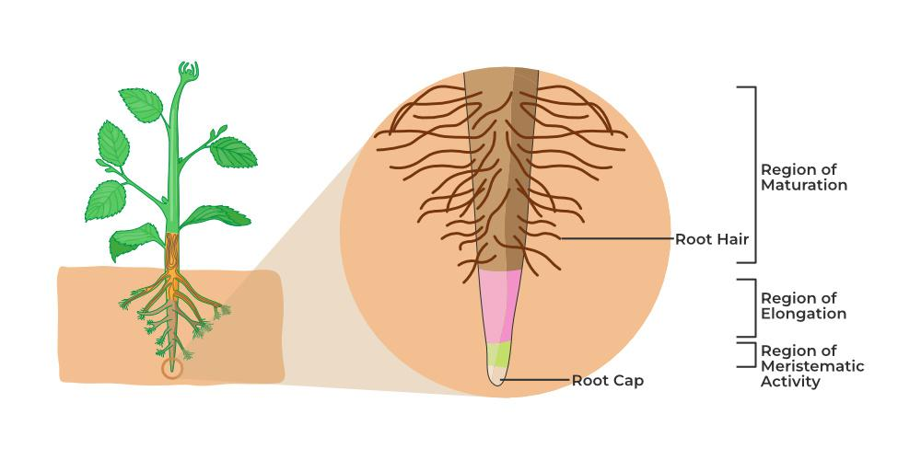

**Types of roots:**

* Tap root (Dicots): Thick primary root with lateral roots (secondary and tertiary roots).
* Fibrous root (Monocots): Numerous thin, hair-like roots.

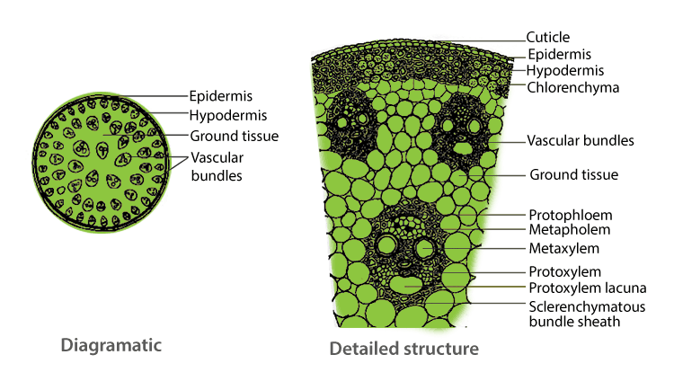

**Internal structure of roots and root hairs:**

* Outermost layer- **epidermis**
* Extensions in the epidermal layer penetrate soil particles called *root hair cells*
* Extensions increase surface area by 67%
* The second layer is the ground tissue called **cortex**
* The inner lining of the cortex is called the **endodermis**, which contains **Casparian strips** (made of suberin) that control water flow.
* Next is the **pericycle** surrounding **vascular bundles**
* Vascular bundles are composed of xylem and phloem vessels arranged in the following way;

1. In monocots– arranged in a ring shape, with central pith
2. In dicots– arranged in a star or cross shape without pith

**8.2.2. Uptake Of Mineral Salts And Water:**

* The two main functions of roots are:

1. Anchoring (supporting) the plant in soil
2. Absorbing essential minerals and water

* **Passive transport** and uptake of nutrients:

1. **Diffusion** – Movement of ions from higher to lower concentration.
2. **Facilitated Diffusion** – Carrier proteins help transport ions.

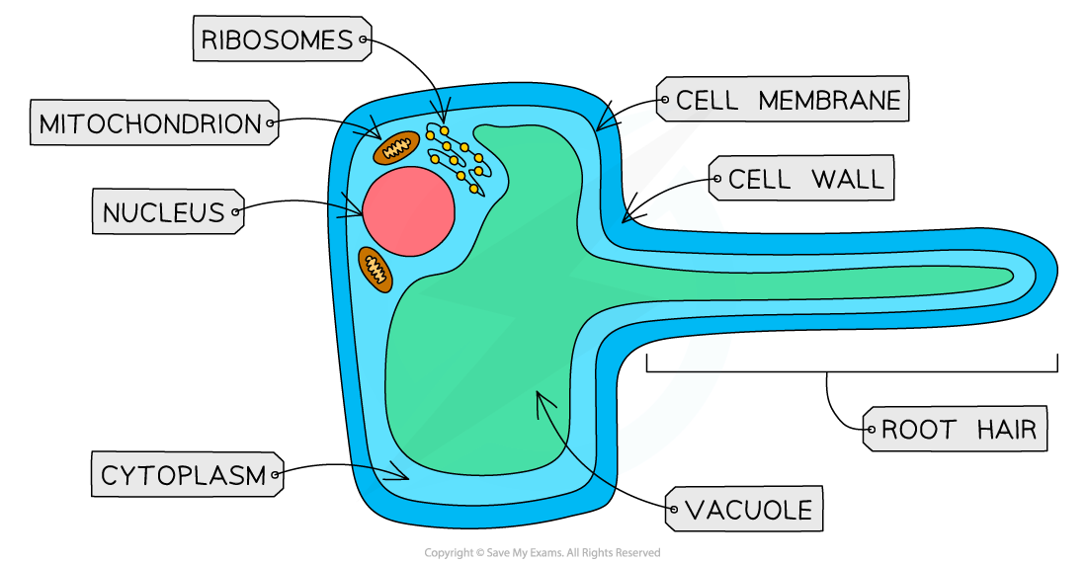

* Passive transport occurs *along* the concentration gradient through plasmodesmata to reach xylem cells
* In facilitated diffusion, the carrier proteins in the cell membrane assist in the movement of nutrients.
* **Active Transport** requires energy in the form of ATP moving the nutrients *against* the concentration gradient.
* It is a selective process, hence it relies on respiration

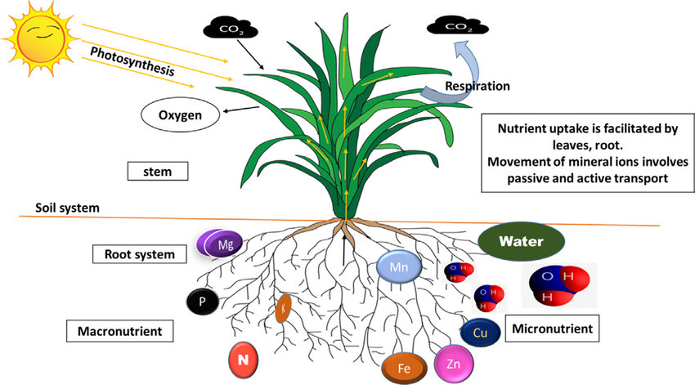

### **Mechanism of Water Absorption by Roots**

* Water is absorbed by **osmosis** (passive transport).
* Osmosis is the movement of **water** molecules from a region of higher **concentration** to a region of lower concentration through a partially permeable **membrane**
* A region of lower water potential to a region of higher water potential
* Moves through:
  + Epidermal cells → Cortex → Endodermis → Pericycle → Xylem.
* **Epidermal cells** are semipermeable, allowing selective entry of water and minerals.

**8.2.3. Transpiration**

* Loss of water in the form of vapours from the aerial parts of plants
* Types of transpiration:

1. Stomatal transpiration– through the stomata in leaves (90%)
2. Cuticular transpiration– through cuticles/leaf surface (7-9 %)
3. Lenticular transpiration– through lenticels/scar-like regions (3%)

### Importance of Transpiration

* Advantages:
  + Cools the plant.
  + Helps in **mineral transport**.
  + Maintains **water movement**.
* Disadvantages:
  + Causes excessive **water loss**.
  + Leads to **wilting** if unchecked.
* Greater rate of transpiration in a large surface area of leaves with more stomata, hence more transpiration in daytime

**8.2.4. Factors Affecting The Rate Of Transpiration**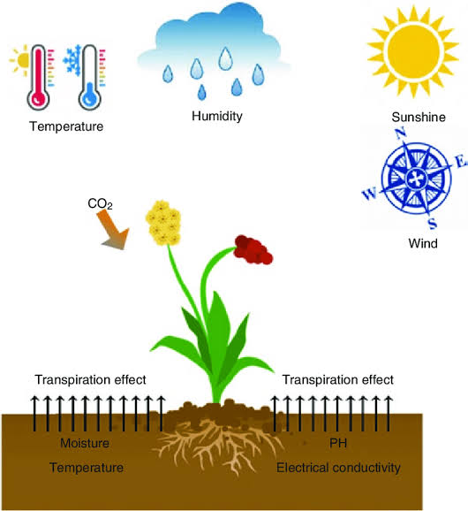

* Environmental factors include temperature, wind, humidity, etc

**Effect of temperature:**

* Higher temperature → More evaporation from mesophyll cells → Increased transpiration.
* Every **10°C** rise doubles the transpiration rate.
* At **40-45°C**, the stomata **close** to prevent excessive water loss.
* Extended high temperatures cause **wilting and death**.

**Effect of wind:**

* Moving air increases **water vapour diffusion**, increasing transpiration.
* Calm air slows transpiration as water vapour accumulates around leaves

**Effect of Humidity:**

* In low humidity, water vapour diffusion is more rapid from the surface of mesophyll cells, air spaces and stomata
* High rate of diffusion leads to more water loss, increasing the rate of transpiration
* In humid air, diffusion slows down, causing a decrease in the rate of transpiration

**Transport of water and salts within the plant body (Ascent of Sap)**

* Root epidermal cells absorb water and salts from the soil
* Substances move from roots to leaves in an upward movement through the xylem called the **ascent of sap.**
* This process of upward movement opposes gravity, especially in tall plants.
* It is said that the ascent of sap occurs due to the **TACT theory**

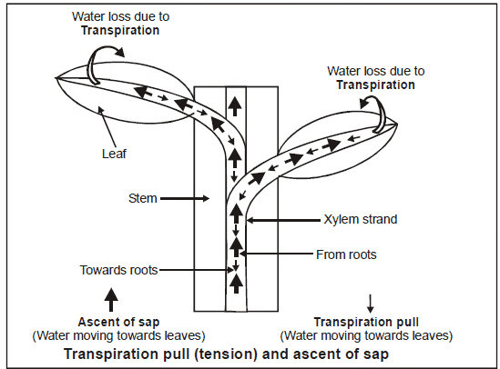

**Passage of Ascent of Sap:**

* Xylem is a **complex and permanent tissue** that acts as a passage for the ascent of sap.
* Types of **xylem cells**:

1. **Tracheids** – Elongated, dead cells with pointed ends.
2. **Vessel Elements** – Tube-like structures formed by the fusion of vessel cells placed end to end.

* Both **tracheids** and **vessels** provide structural support and transport functions.

**TACT theory:**

* **TACT** stands for:

1. Transpiration Pull
2. Adhesion
3. Cohesion
4. Tension

These four factors create a force that moves water and minerals upward in plants.

### **1) Transpiration Pull**

* Water evaporates from the stomata, creating a **pulling force** known as **transpiration**.
* This force draws water up from the roots through the **xylem**.

### **2) Adhesion**

* Adhesion is the **attraction between water molecules and other substances**.
* Water molecules are strongly attracted to **xylem cell walls** (made of cellulose), which helps water move upwards.

### **3) Cohesion and Tension**

* **Cohesion**: Water molecules are **polar**, meaning they attract each other and stick together.
* **Tension**: As water evaporates, a **negative pressure (tension)** is created in the xylem, pulling water upward like a **continuous column**.

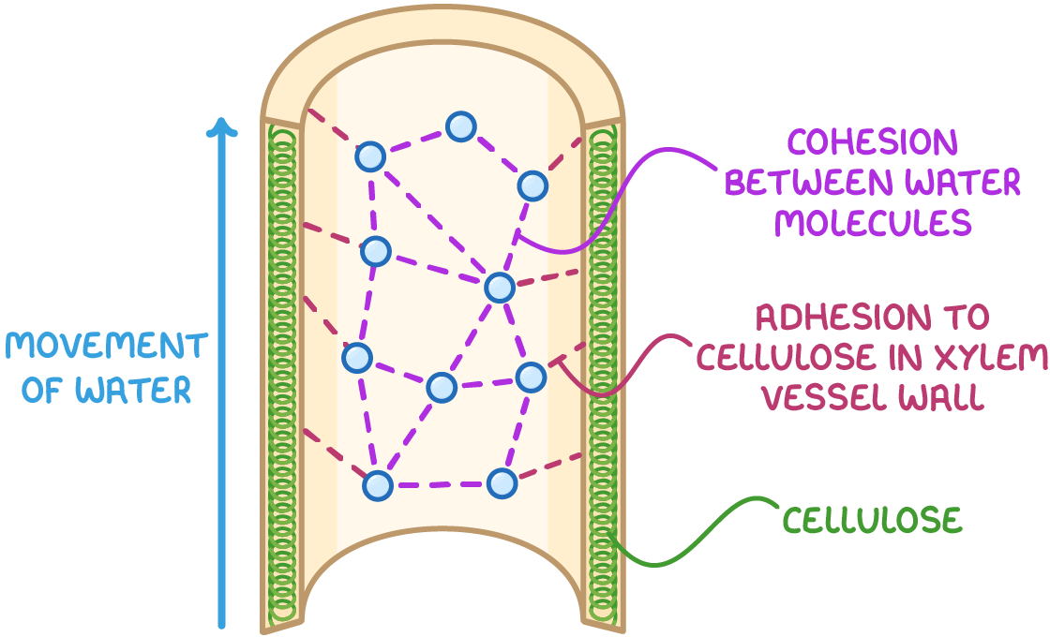

### **How TACT Force Works**

* Water in the xylem forms a continuous **column**, similar to a **steel wire** held together by hydrogen bonds.
* As long as **transpiration continues**, water remains **tense** and gets pulled upwards.
* This process is **driven by solar energy** since the **evaporation of water from leaves** maintains the transpiration pull.

**8.2.5. Transport Of Organic Solute Within Plant Body:**

* Translocation is the movement of **prepared food (organic solutes)** through the phloem.
* Food moves from **source** (producing organs like leaves) to **sink** (consuming organs like roots, fruits, and storage tissues).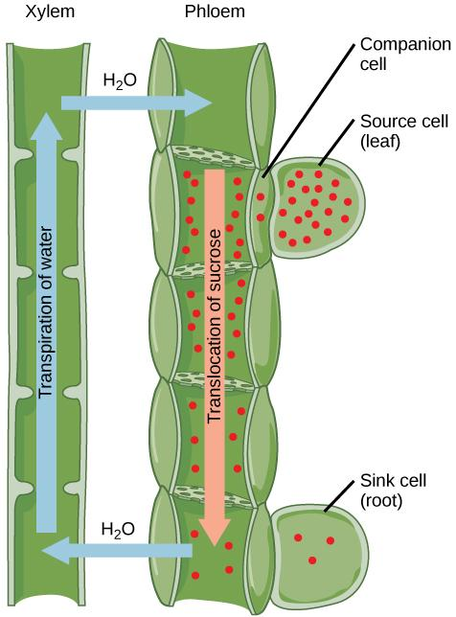

**Passage of Translocation:**

* Occurs through phloem tissues, which consist of:

1. **Sieve Tube Elements** – Long, tube-like structures that transport solutes.
2. **Companion Cells** – Control the transport process.

**Direction of Translocation:**

* The direction of movement is not just upward, but it can also move in various directions
* It's a source to sink movement
* Sources are the organs that produce food (e.g., leaves), and sinks are the organs that store or consume food (e.g., roots and fruits)

**Composition of Phloem sap:** 10-25% dry matter, mainly sucrose and other organic compounds

**Mechanism of Translocation: (Pressure Flow or Mass Flow Theory)**

1. Sucrose (sugars produced in source) is loaded into sieve tube elements by companion cells
2. This increases sugar concentration, reducing water potential and causing water to move through osmosis into the phloem.
3. Water entry increases hydrostatic pressure, pushing sap away from the source.
4. The pressure difference pushes sap toward the sink (lower-pressure area).
5. At the sink, sucrose is actively removed and stored.
6. Water potential increases, allowing excess water to flow back into the xylem.

**8.3. Gas Exchange In Plants**

* Gas exchange is a type of respiration that occurs at the organism level in plants. It ensures that:
* Plants receive oxygen for cellular respiration.
* Carbon dioxide, a byproduct of respiration, is removed.
* Gas exchange primarily happens through **stomata (leaf openings)** and **lenticels (stem openings)** via diffusion.

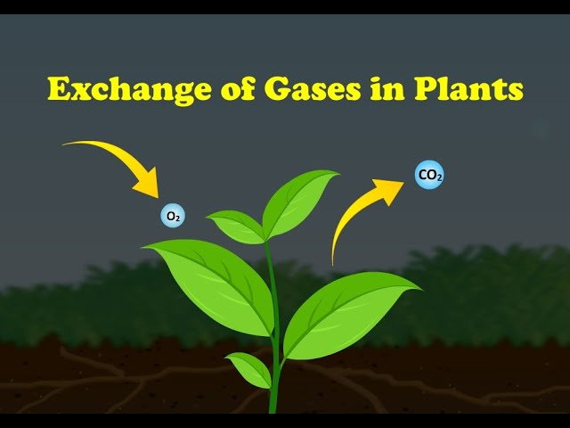

**8.3.1. Pattern Of Gas Exchange In Leaves:**

* Plants, being photosynthetic autotrophs, show different gas exchange patterns in the day and night:
* **In daytime,** theinhaled gas is Carbon dioxide while the exhaled gas is Oxygen (reason: photosynthesis is actively going on)
* **At nighttime,** inhaled gas is oxygen while exhaled gas is carbon dioxide (reason: photosynthesis stopped, respiration going on)
* **Compensation point:** during dawn and dusk, when light intensity is low, the rate of photosynthesis equals the rate of respiration, leading to no net gas exchange.

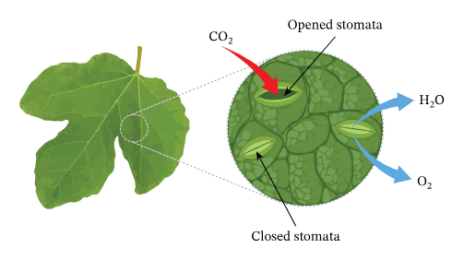

**8.3.2. Pattern Of Gas Exchange In Roots:**

* Roots absorb oxygen from the soil air and release carbon dioxide through root epidermal cells.
* This process remains the **same during the day and night** since roots do not perform photosynthesis.

**8.4. Homeostasis in Plants**

Homeostasis refers to how plants adjust to varying environmental conditions, including temperature, water, and salt levels in the soil.

**8.4.1. Importance Of Homeostasis:**

* Homeostasis ensures plant growth, survival and reproduction
* Helps plants withstand **temperature fluctuations**
* Maintain hydration levels
* Supports adaptation to stressors like **drought, salinity, and herbivory**.
* Allows plants to regulate internal stability and contribute to ecological balance.

**8.4.2. Excretion In Plants:**

* Unlike animals, plant excretion involves the removal of gases, water, and waste compounds through various processes:

1. **Excretion of carbon dioxide and water**

* **CO₂** is excreted at night due to respiration.
* **O₂** is excreted during the day due to photosynthesis.

1. **Excretion of water**

* Water is excreted through transpiration and as a byproduct of photosynthesis and respiration.

1. **Excretion through leaves**

* Vacuoles store organic/inorganic waste compounds.
* Leaves remove excess materials, sometimes leading to **yellowing** (not due to chlorosis but due to stored waste).
* **Excretophores**: Fallen leaves act as organs of excretion.

1. **Excretion through stem and branches**

* Some trees (e.g., **ebony trees**) store waste chemicals in old **xylem tissue**, making the wood darker.

1. **Excretion through roots**

* Some plants release **toxic waste chemicals** into the soil to prevent competition from other plants (**allelopathy**).
* **Conifer trees** use this method effectively by making the soil more acidic and preventing other plants from growing nearby

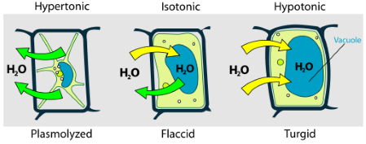

**8.4.3. Osmotic Adjustment (Osmoregulation)**

* Osmoregulation refers to how plants regulate water and solute levels in cells.
* **Hypotonic situation,** water enters the cell, making it swollen and firm (turgid). More water content, less solute
* **Hypertonic situation:** water leaves the cell, making it shrink and limp (flaccid). More solute content, less water
* **Isotonic situation:** ideal balance of water and solutes inside and outside the cell; hence, no net movement

**Osmotic Adjustment in different plant groups:**

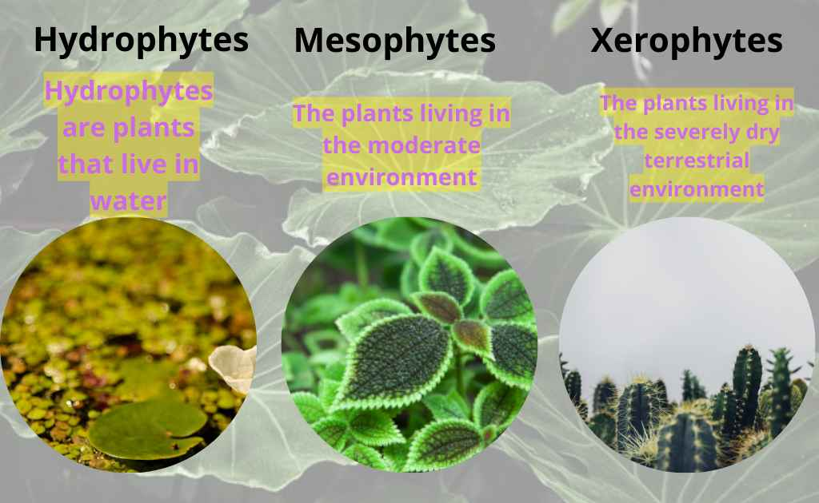

1. **Hydrophytes**

* In aquatic plants
* The transpiration rate is high
* Stomata on the upper leaf surface
* Thin cuticle

1. **Mesophytes**

* In moderate water plants
* Stomata on the lower leaf surface
* Open during the day, closed at night

1. **Xerophytes**

* In desert plants
* Low transpiration rate
* Sunken stomata to prevent water loss
* Thick cuticles and fleshy leaves to store water, known as **succulents**



